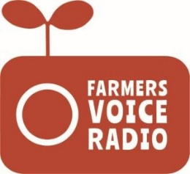

Farmers’ Voice Radio Reflective Diary Template
for Programme Reference Group Members

Name of farmer
Sex (M/F)
Community
Any disability? (Y/N)

Q1: What did you discuss in the Programme Reference Group meetings and hear in the radio programmes during the last month?

Q2: What information discussed in the Programme Reference Group meetings and/or broadcast on the radio programmes was most useful to your cocoa farming/other livelihood activities?

Q3: What did you do with the knowledge gained from the group discussion? (e.g. tell anyone, who? Change your farming practices? Get more involved in the farmer association?... other reflections?)

Q4: How did the new information change your views about what you should do with your cocoa farm / other crops and livelihood activities?

Q5: Any other reflections or other consequences of the radio and group discussions?

